What to Bring
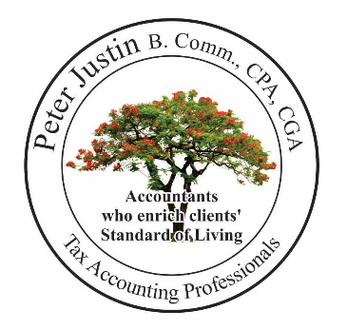

Income Tax Filing

___ Notice of Assessment
____ All mail from Revenue Canada

Income: T-Slips
___: T4: Employment Income
___: T4A(OAS): Old Age Security, Foreign Pension
___: T4A(P): CPP, Survivor, Disability, Child, Benefits
___: RC62: Universal Child Care Benefit
___: T4E: Employment Insurance
___: T3, T5: Capital Gain, Interest, Dividends, Mutual Funds
___: T4A: Other Pension, Retiring, Annuities, Grants, Scholarship
___: T4RSP: RRSP withdrawal
___: T5007: Social assistance payments, Workers compensation

Deductions:
___: RRSP contribution slips
___: Professional or union dues
___: Child care expenses
___: Moving expenses
___: Carrying charges and interests paid on Investment Income
___: Employment Expense Automobile, Travel Ex. with logbook and T2202
___: Clergy residence deduction

Non-refundable credit
___: Volunteer firefighter, Search and rescue amounts [letter from authorized body]
___: Transit passes; __TTC, __GO, __, GTA, __Presto [not tickets]
___: Children’s fitness amounts
___: Children Arts and Music amounts
___: Home buyers amount [House bought document]
___: Medical Expenses, Dental, Eye,
___: Charitable donations
___: Political contributions

Student
___: T4A: Scholarships, Bursaries, Grants, from Ministry of Training, RESP, University
___: T2202A: Tuition, Education Textbook Amounts
[print from university’s or college’s Web under your student number]
___: TL11A, B, C: -Student from Foreign University, Flying school, Post-secondary education
___: Interest paid on student loans [OSAP program loans only]

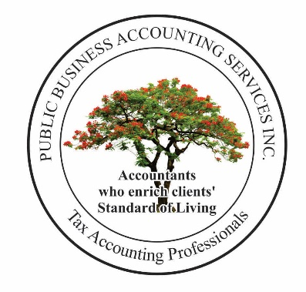Parents claiming Children who are age under 18
___: First name, Last name & Date of Birth
___: RC-62 UCCB

Caregiver dependent
___: Senior parents age over 65:
First, Last name, Date of Birth, SIN,
Total Income
___: The tax filer and their parents’ address must be the same

Disable Dependent
___: Form T2201 signed & Disability Tax Credit Certificate

Other document
___: Rent
___: Property tax

Business Rental Income & Gains

Rental Income and Related Expenses
___: Rental Income
___: Mortgage Interest [statement from bank]
___: Property Tax
___: House Insurance
___: Repair & Maintenance
___: Utilities [hydro, gas, water, cable]
___: CCA method: Total costs of the property [documents from Lawyer + costs of additions + renovation]

Capital Gain on Sale of a Property
___: Purchase documents [Lawyer given to you}
___: Sales documents [Lawyer given to you]

Stock Trading
___: Stock Trading Summary

Business Income and Related Expenses
___: Income, Expenses
___: GST/HST returns

Phone List
Service Canada monitors “Canada’s Social Security System”
Income Security

For
Old Age Security Pension [OAS] & Guaranteed Income Supplement [GIS]
Canada Pension Plan [CPP]
Disability Pension [CPP D]
And
Employment Insurance

Call 1-800-277-9914

Go online www.cra-arc.gc.ca/myaccount/
And open “My account” to view or print
___: for Notice of Assessment,
___: and related tax matters

We Will Help You: Please Visit

Peter Justin Chartered Professional Accountant
Public Business Accounting Services Inc.
11-1415 Kennedy Road, Toronto ON M1P 2L6, Tel: 416-321-3100, Fax: 416-321-8400
Email: PublicAccounting@bellnet.ca

