How the Rich get Richer?

What Is Financial Literacy?

Ability to make appropriate decisions on investments
Ability to assess and evaluate avenues of alternatives and opportunity costs before the investments are made

Buying any property or business is not always an Investment.
An investment must generate monthly income and future capital gain
Assessing ₁valuation, ₂risk factor and ₃rate of return on investment is a smart step.

New Investors fail to understand the risks associated with investments!
Risk is the possibility of losing some or all of the original amounts invested.

Starting a business a good Idea? Yeah but,
Hard work will not create consistent profit!
Management techniques, marketing talents, quality of product or service will create profit.

“Higher the risk the higher the return” is very wrong
“Higher the risk the higher the return or higher the loss” is True!
Taking risk: at what age? What portion of my income?

Investing in stocks, currency & commodity trading or a mutual fund?
Meet at least two people who have really gained in the Money Trading!
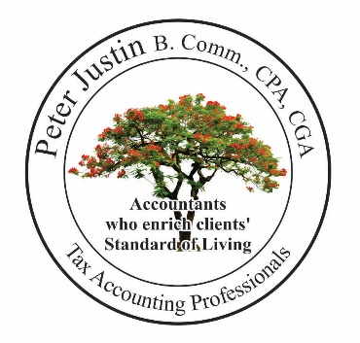
What Is Financial Literacy?

When I buy vegetables or fish from a Poor Vendor for $30.00
How many questions do I ask the poor vendor?
What ‘knowledge level’ do I have? to determine the price of the vegetable?
When I buy a property or business from a rich vendor for $1,000,000.00
How many questions do I ask the rich vendor?
What ‘knowledge level’ do I have to determine the true value?

Investment advisors in a suit with colorful documents can deceive us into blindly accepting their offers for their benefit.
Am I smart enough to determine what to do with my money without other people influencing me or taking control?

True Market Value of Investment [Is my investment safe?]
Buy a business, Investment or a property at the amount equal to the true value of the business or property.
‘True value’ means “Am I able sell the business or property next day, if necessary, at the price I paid today?

Risk Factor

There is always a risk associated with any business or investment.
‘The risk’ means “A certainty of a profit or the potential for financial loss” in the business or investment.
Assess the risk factor to determine whether the business or investment is worth buying?
By doing this my Investment is Safe!

Peter Justin Chartered Professional Accountant
March16, 2015
Richness of life is achieved by having a “Happy Healthy Life”

