Stay Smart on Financial Matters
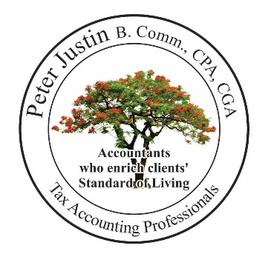

Financial Success is ‘having some material assets’
Life Success is ‘enjoying a level of comfort and quality of lifestyle’
Richness of Life is having a ‘Happy Pleasant Life’

Valuation & Financial Literacy! Why is it Important?
Our Lifelong saving may result in questions

We know how to earn money but do not know how to have a happy life out of it
Many don’t know how to handle money; they give their money to someone
thinking they are trustworthy and expect an Interest and the return of their money whenever needed,
finally they lose their hard-earned money.

Plan and evaluate before buying a property, business, mutual funds or stocks!

Jumping into the unknown and hoping for the best is a risky business
Before I jump into any investment, take a paper and pen and write-down all costs involved.
Calculate income and assess legal, tax issues and stress level of carrying another loan and responsibility at my age.

Don’t get caught in the marketing hype [under influence of ‘Greed’ or ‘Hope’
First marketing agencies sell you GREED; under their persuasion, you end up buying the product or service.
Some smart marketing agencies sell you HOPE; with this reasoning, you end up buying the product or service.

Marketing agencies spend millions of dollars on marketing and promoting to launch a new product or service.
It is incredibly easy to get lost in the vortex of a marketer’s trick.

Don’t be fooled into overpaying for a product;
Simply to get points, rewards, cash-back, free-gift, discounts or promotions

Tax Accounting Professionals

Accountants who enrich our clients’ standard of living

