The world in which we are the boss

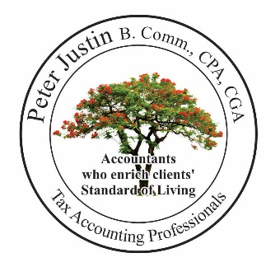

Starting a Business
Professional Practice
Not-For-Profit or
Charity?

Follow the Steps or Visit us

___ 1- Select an Accountant and Attorney
___ 2- Prepare a Business Plan

___ 3- Registering with a legal ending: Limited, Corporation, Ltd., Inc.,
___ 4- Style Name under a corporation: Master Business License
___ 5- Business Name Registration: Proprietorship, Partnership: Master Business License

___ General Business Corporation
-a Factory, Restaurant, Convenience Store, Trucking etc.,
___ Professional Corporation, Limited Liability Partnership
-a Law, Medical, Accounting, Engineering, Optometry, Dental, etc..,
___ Not-For-Profit
-a Social, Sports Clubs, Professional Association,
___ Registered Charity
-a Religious, Charitable organization

___ 6- Lease and Business/Practice License
*You require a business license or permit to operate a business or practice in your city.
*Contact your city's business license department to find out about getting a license to operate a business within that city.
*Make sure with your city zoning department that your premise is zoned for the purpose for which you want to use it.

___ 7- Apply for Federal and Provincial Tax Number to operate your business!
GST/HST: ______, Payroll: ______, WSIB: ______, HT:______
___ 8- Open a business bank account
___ 9- Obtain business insurance
___ 10- Create contracts and put agreed orders in writing
___ 11- Develop a marketing plan for your products and services.

A corporation [limited company] may protect your personal assets
If a business operates as a corporation, the business owners who are called “shareholders”
are not personally liable for debts or other claims against the corporation.

The corporation is a separate legal entity from its owners.

If a corporation complies with the corporation acts, Income Tax Acts, and regulations,
it is treated as a separate legal entity.

If a borrower is a corporation, creditors and lenders enforce a claim against the corporation but
not against the shareholders.

A corporation’s asset belongs to the corporation until all loans, liens, payables and taxes are paid in full.

Peter Justin Chartered Professional Accountant
Public Business Accounting Services Inc.
11-1415 Kennedy Road, Toronto ON M1P 2L6, Tel: 416-321-3100, Fax: 416-321-8400
Email: PublicAccounting@bellnet.ca, /www.PublicBusinessAccounting.com

