Do I need an accountant?

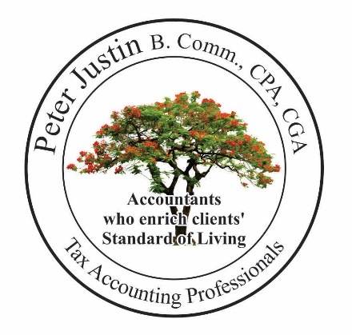
We take the fear out of Accounting, Auditing and Income Tax

How to start a business?

Why a partnership does not work for you?

Does your business pay you salary and profit?

Franchise Business? Issues

Buying a property under a corporation - Is it a tax saving?

Income Tax Issues? The CRA’s Audits?

What is the best investment in the world?
Investing in properties? Buying a condo unit?

Buying a property, renovating and selling?
Canadian owns property in the USA?
Non-residents owns property in Canada?

Tax clearance certificate?

Child tax benefits issues?
RRSP?
Pension?
Tax Free Saving Accounts? Think before you invest

How many hours do you and your spouse work in a week?
How many hours do you spend with your family and children?

New housing GST/HST Rebate may surprise you!
___ Did I buy a new house or condo?
___ Did I sell a new house within one year?

Filing Income Tax
___ Immigrant, Emigrant Tax
___ Non-resident Tax
___ Did I declare my foreign property on my Income tax
___ Residential, commercial property rental

Our best wishes to you and your family

